DIS-MEX-Colima-Shaft Grave Mortuary Vessel

Height: 23 in. Bouck Estate, New York City, 2015

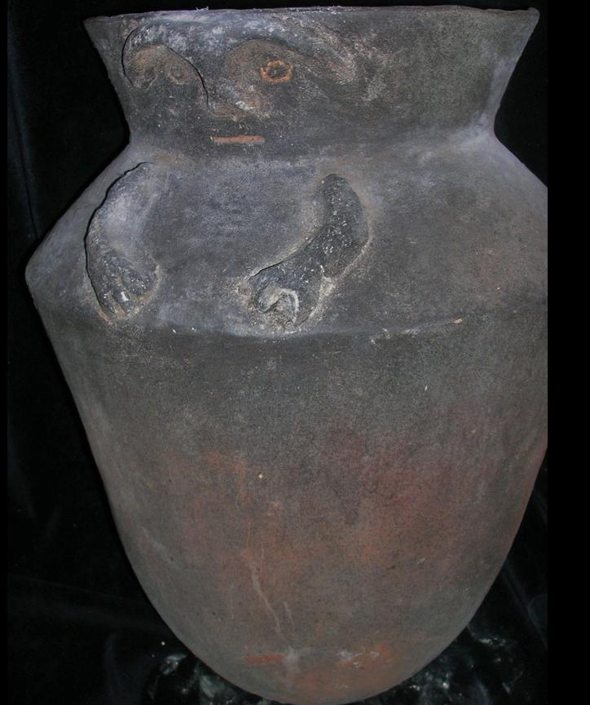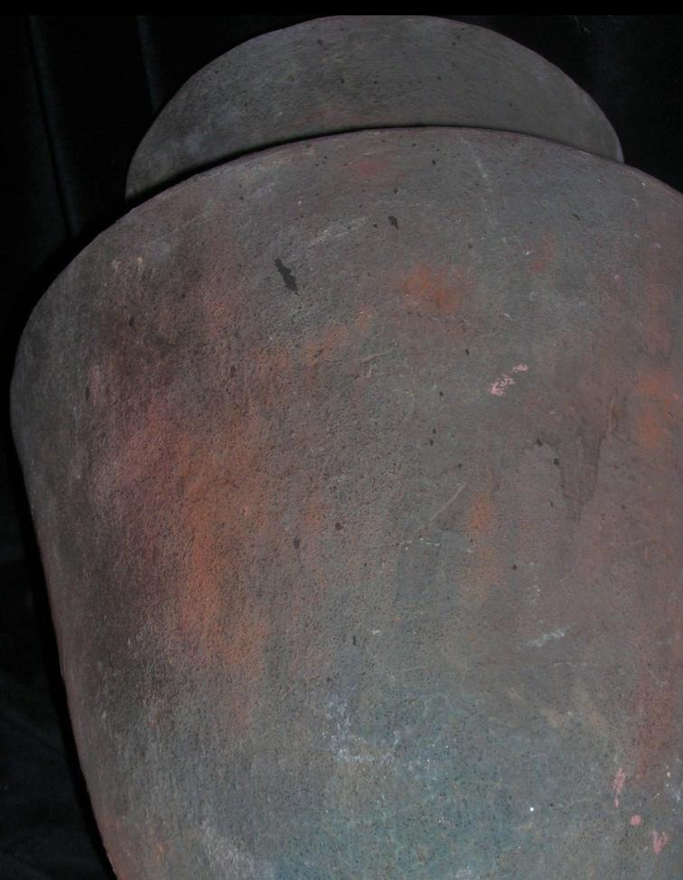

# Order details

## Sales order

Sold by [primitifstuffgal...](http://myworld.ebay.com/primitifstuffgallery) ( [2056](http://feedback.ebay.com/ws/eBayISAPI.dll?ViewFeedback&userid=primitifstuffgallery) )

### Delivery package 1 of 1

Estimated delivery Wednesday, Jan 27, 2016 - Saturday, Jan 30, 2016

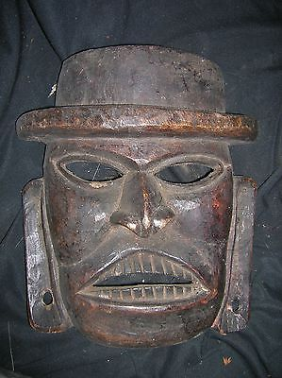

#### [NEPAL SHAMAN HUGE MASK 20" EARLY 1900S](http://www.ebay.com/itm/321971259442)

|  |  |
| --- | --- |
| Item price | $79.99 |
| Quantity | 1 |
| Item number | 321971259442 |
| Shipping service | USPS Priority Mail |

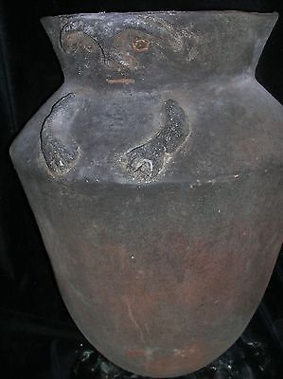

#### [orig $499 PRE COLUMBIAN COLOMBIA COLIMA CAVE/CRYPT URN FIGURE 23"](http://www.ebay.com/itm/321973258469)

|  |  |
| --- | --- |
| Item price | $249.99 |
| Quantity | 1 |
| Item number | 321973258469 |
| Shipping service | USPS Priority Mail |

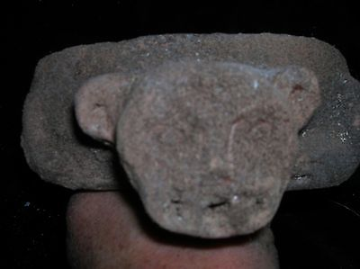

#### [PRE CONTACT MAYAN CAVE/CRYPT JAGUAR BOWL FIGURE 10"](http://www.ebay.com/itm/321975624653)

|  |  |
| --- | --- |
| Item price | $159.99 |
| Quantity | 1 |
| Item number | 321975624653 |
| Shipping service | USPS Priority Mail |

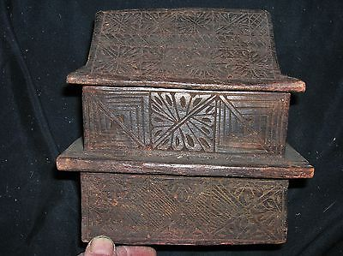

#### [NEPAL SHAMANS RITUAL BOX 7" EARLY 1900S](http://www.ebay.com/itm/321981716753)

|  |  |
| --- | --- |
| Item price | $59.99 |
| Quantity | 1 |
| Item number | 321981716753 |
| Shipping service | USPS Priority Mail |

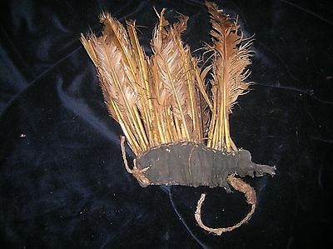

#### [NEPAL SHAMAN HEADPIECE FEATHERS EARLY 1900S](http://www.ebay.com/itm/321981716761)

|  |  |
| --- | --- |
| Item price | $69.99 |
| Quantity | 1 |
| Item number | 321981716761 |
| Shipping service | USPS Priority Mail |

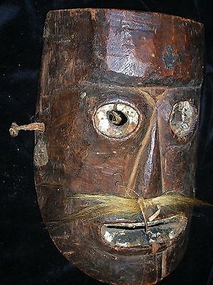

#### [NEPAL SHAMAN MASK, METAL, EARLY 1900S](http://www.ebay.com/itm/321981716765)

|  |  |
| --- | --- |
| Item price | $99.99 |
| Quantity | 1 |
| Item number | 321981716765 |
| Shipping service | USPS Priority Mail |

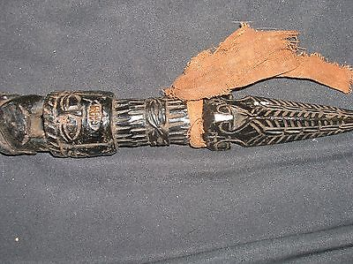

#### [NEPAL SHAMANS PHURBA 10" EARLY 1900S](http://www.ebay.com/itm/221999873011)

|  |  |
| --- | --- |
| Item price | $59.99 |
| Quantity | 1 |
| Item number | 221999873011 |
| Shipping service | USPS Priority Mail |

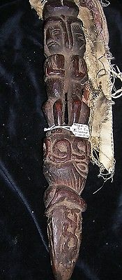

#### [NEPAL SHAMAN HUGE STAFF, 4 FIGURES, HUGE 20" EARLY 1900S](http://www.ebay.com/itm/221999873030)

|  |  |
| --- | --- |
| Item price | $139.99 |
| Quantity | 1 |
| Item number | 221999873030 |
| Shipping service | USPS Priority Mail |